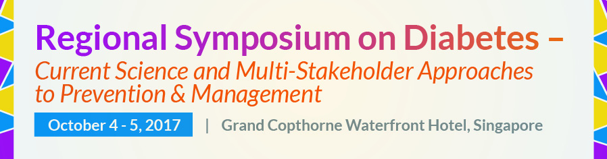

Poster Abstract Submission Template
Kindly fill in the details below and submit the completed form to ilsisea@ilsisea.org.sg with the email heading “Regional Symposium on Diabetes: Poster Abstract Submission” by September 4, 2017.
For guidelines on poster abstract submission, please refer to the “Poster” tab on http://ilsisea-region.org/diabetes2017.
Title of Poster Abstract

Poster Categories
Kindly tick the category which the poster abstract falls in.

□ Diabetes Prevalence & Risk Factors
□ Diet and Lifestyle Factors in Prevention and Management of Diabetes
□ Intervention and Community Programs through Collaborative Strategies and Approaches
□ Product Innovations
□ Tools and New Technologies for Education

List of Authors and Affiliations
Kindly underline the presenter’s name.

Presenter’s Information

Name:
Email:
Contact Number (please include country and area codes):

Abstract
Kindly note the word limit of 300 words.

References

